 | 12-15 November  Republic of Belarus,  Minsk, Pobedetiley Ave., 20/2  Football arena | APPLICATION 1  Prices for services  for foreign participants
Tariffs are indicated in Belarusian rubles, excluding VAT, VAT - 20%.
REGISTRATION FEE*……………………………………..……………….654,45 BYN + VAT
*obligatory for all exhibitors and Co-exhibitors
(includes general organization expenses: information stand services, accreditation of 4 representatives of the Company submitting badges to the fair, 10 printed invitation cards, general advertising of the fair; catalogue entry indicating information about the Company, two invitation cards to the business cocktail).

TYPICAL STAND

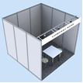 | Includes: indoor unequipped exhibition area, wall panels from 3 sides, a fascia panel with Company name, floor covering, a socket, lamps (one per each 3 sq.m. of a booth), 1 table 800x800, 2 chairs semi-soft, a rack, a paper tray).
Typical stand 9
Depending on the location of the stand, the tariff for an unequipped area increases.
corner stand (open on 2 sides) | markup | stand (open on 3 sides) | markup | stand (open on 4 sides) | markup
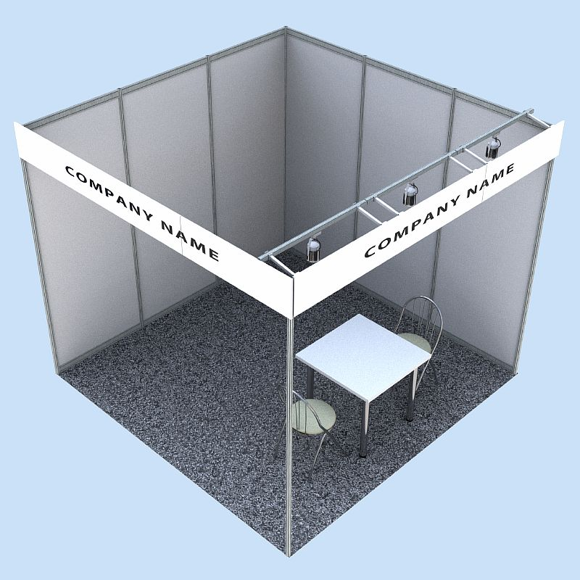 | 10% | 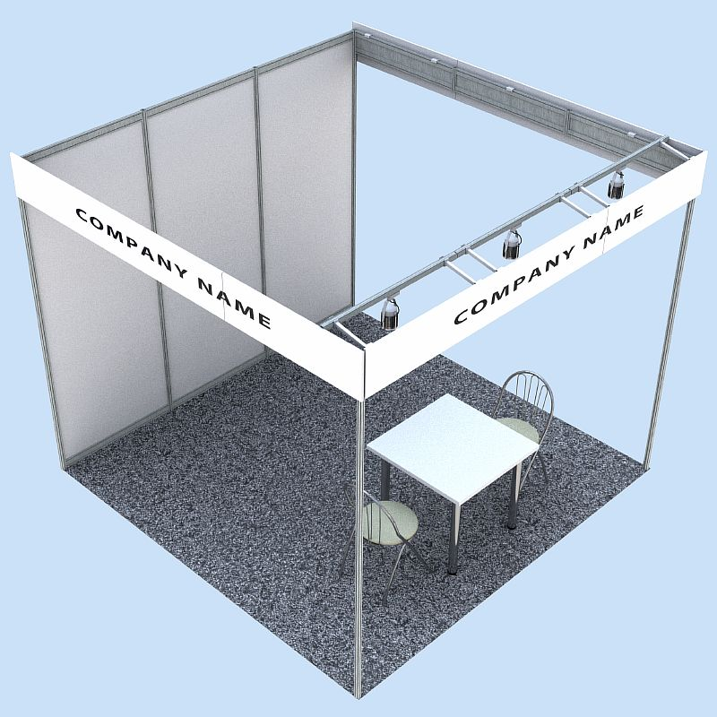 | 20% | 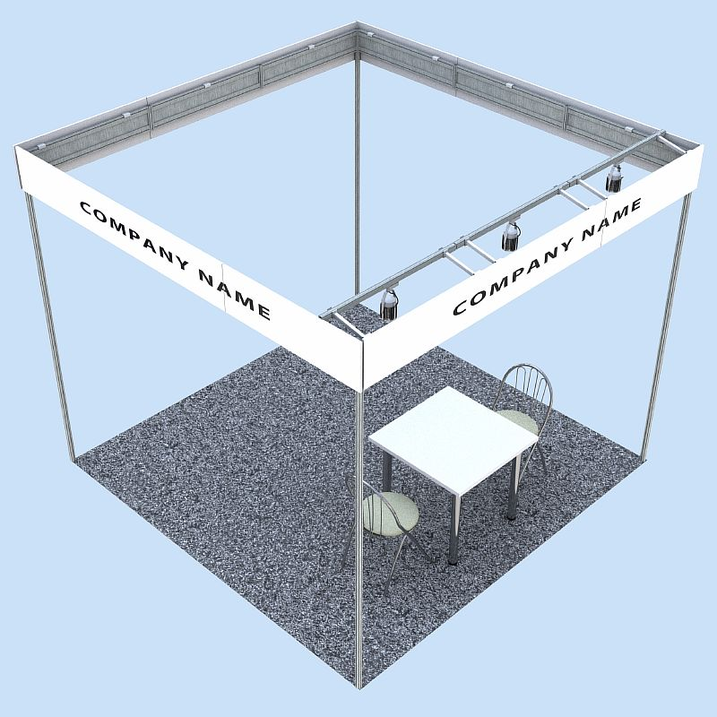 | 30%

When constructing a stand by the Exhibitor or with the involvement of a third party, the cost
1 sq.m. unequipped exhibition space increases by 40%.

30th international specialized wholesale exhibition-fair «PRODEXPO-2024»

TARIFFS
Location  Space area | Typical | Open on 2 side | Open on 3 side | Open on 4 side  (from 24 sq.m.)
4 sq.m. | 1996,86 | 2088,98 | 2181,14 | -
6 sq.m. | 2692,22 | 2831,38 | 2970,60 | -
9 sq.m. | 3709,09 | 3835,31 | 3961,62 | -
12 sq.m. | 4731,96 | 4953,92 | 5227,57 | -
15 sq.m. | 5820,36 | 6093,31 | 6366,41 | -
18 sq.m. | 6818,05 | 7161,56 | 7505,25 | -
For standard stands with an area over 18 sq.m. Tariff available upon request.
Unequipped exhibition space | 235,24 | 258,76 | 282,29 | 305,81
Unequipped area, taking into account construction by the exhibitor or a third party | 329,34 | 352,86 | 376,38 | 399,91

ABSENTEE PARTICIPATION
(placement of materials on the organizer’s information stand without the presence of the exhibition) …………………………………………………………………………..…………..……………500,00

